Array in Data Structure

In this article, we will discuss the array in data structure. Arrays are defined as the collection of similar types of data items stored at contiguous memory locations. It is one of the simplest data structures where each data element can be randomly accessed by using its index number.

In C programming, they are the derived data types that can store the primitive type of data such as int, char, double, float, etc. For example, if we want to store the marks of a student in 6 subjects, then we don't need to define a different variable for the marks in different subjects. Instead, we can define an array that can store the marks in each subject at the contiguous memory locations.

Properties of array

There are some of the properties of an array that are listed as follows -

* Each element in an array is of the same data type and carries the same size that is 4 bytes.
* Elements in the array are stored at contiguous memory locations from which the first element is stored at the smallest memory location.
* Elements of the array can be randomly accessed since we can calculate the address of each element of the array with the given base address and the size of the data element.

Representation of an array

We can represent an array in various ways in different programming languages. As an illustration, let's see the declaration of array in C language -

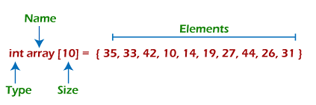

As per the above illustration, there are some of the following important points -

* Index starts with 0.
* The array's length is 10, which means we can store 10 elements.
* Each element in the array can be accessed via its index.

Why are arrays required?

Arrays are useful because -

* Sorting and searching a value in an array is easier.
* Arrays are best to process multiple values quickly and easily.
* **Arrays are good for storing multiple values in a single variable -** In computer programming, most cases require storing a large number of data of a similar type. To store such an amount of data, we need to define a large number of variables. It would be very difficult to remember the names of all the variables while writing the programs. Instead of naming all the variables with a different name, it is better to define an array and store all the elements into it.

Memory allocation of an array

As stated above, all the data elements of an array are stored at contiguous locations in the main memory. The name of the array represents the base address or the address of the first element in the main memory. Each element of the array is represented by proper indexing.

We can define the indexing of an array in the below ways -

1. 0 (zero-based indexing): The first element of the array will be arr[0].
2. 1 (one-based indexing): The first element of the array will be arr[1].
3. n (n - based indexing): The first element of the array can reside at any random index number.

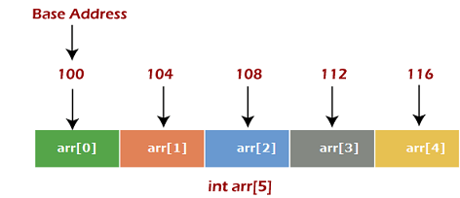

In the above image, we have shown the memory allocation of an array arr of size 5. The array follows a 0-based indexing approach. The base address of the array is 100 bytes. It is the address of arr[0]. Here, the size of the data type used is 4 bytes; therefore, each element will take 4 bytes in the memory.

How to access an element from the array?

We required the information given below to access any random element from the array -

* Base Address of the array.
* Size of an element in bytes.
* Type of indexing, array follows.

The formula to calculate the address to access an array element -

1. Byte address of element A[i]  = base address + size * ( i - first index)

Here, size represents the memory taken by the primitive data types. As an instance, **int** takes 2 bytes, **float** takes 4 bytes of memory space in C programming.

We can understand it with the help of an example -

Suppose an array, A[-10 ..... +2 ] having Base address (BA) = 999 and size of an element = 2 bytes, find the location of A[-1].

L(A[-1]) = 999 + 2 x [(-1) - (-10)]

= 999 + 18

= 1017

Basic operations

Now, let's discuss the basic operations supported in the array -

* Traversal - This operation is used to print the elements of the array.
* Insertion - It is used to add an element at a particular index.
* Deletion - It is used to delete an element from a particular index.
* Search - It is used to search an element using the given index or by the value.
* Update - It updates an element at a particular index.

Traversal operation

This operation is performed to traverse through the array elements. It prints all array elements one after another. We can understand it with the below program -

#include <stdio.h>

**void** main() {

**int** Arr[5] = {18, 30, 15, 70, 12};

**int** i;

   printf("Elements of the array are:\n");

**for**(i = 0; i<5; i++) {

      printf("Arr[%d] = %d,  ", i, Arr[i]);

   }

}

**Output**

Array in DS

Insertion operation

This operation is performed to insert one or more elements into the array. As per the requirements, an element can be added at the beginning, end, or at any index of the array. Now, let's see the implementation of inserting an element into the array.

#include <stdio.h>

**int** main()

{

**int** arr[20] = { 18, 30, 15, 70, 12 };

**int** i, x, pos, n = 5;

    printf("Array elements before insertion\n");

**for** (i = 0; i < n; i++)

        printf("%d ", arr[i]);

    printf("\n");

    x = 50; // element to be inserted

    pos = 4;

    n++;

**for** (i = n-1; i >= pos; i--)

        arr[i] = arr[i - 1];

    arr[pos - 1] = x;

    printf("Array elements after insertion\n");

**for** (i = 0; i < n; i++)

        printf("%d ", arr[i]);

    printf("\n");

**return** 0;

}

**Output**

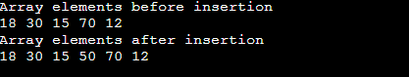

Deletion operation

As the name implies, this operation removes an element from the array and then reorganizes all of the array elements.

#include <stdio.h>

**void** main() {

**int** arr[] = {18, 30, 15, 70, 12};

**int** k = 30, n = 5;

**int** i, j;

   printf("Given array elements are :\n");

**for**(i = 0; i<n; i++) {

      printf("arr[%d] = %d,  ", i, arr[i]);

   }

   j = k;

**while**( j < n) {

      arr[j-1] = arr[j];

      j = j + 1;

   }

   n = n -1;

   printf("\nElements of array after deletion:\n");

**for**(i = 0; i<n; i++) {

      printf("arr[%d] = %d,  ", i, arr[i]);

   }

}

**Output**

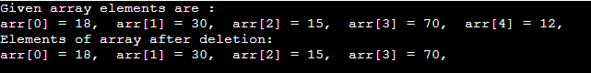

Search operation

This operation is performed to search an element in the array based on the value or index.

#include <stdio.h>

**void** main() {

**int** arr[5] = {18, 30, 15, 70, 12};

**int** item = 70, i, j=0 ;

   printf("Given array elements are :\n");

**for**(i = 0; i<5; i++) {

      printf("arr[%d] = %d,  ", i, arr[i]);

   }

    printf("\nElement to be searched = %d", item);

**while**( j < 5){

**if**( arr[j] == item ) {

**break**;

      }

      j = j + 1;

   }

   printf("\nElement %d is found at %d position", item, j+1);

}

**Output**

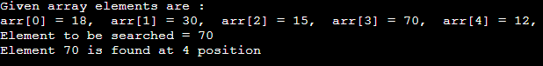

Update operation

This operation is performed to update an existing array element located at the given index.

#include <stdio.h>

**void** main() {

**int** arr[5] = {18, 30, 15, 70, 12};

**int** item = 50, i, pos = 3;

   printf("Given array elements are :\n");

**for**(i = 0; i<5; i++) {

      printf("arr[%d] = %d,  ", i, arr[i]);

   }

arr[pos-1] = item;

   printf("\nArray elements after updation :\n");

**for**(i = 0; i<5; i++) {

      printf("arr[%d] = %d,  ", i, arr[i]);

   }

}

**Output**

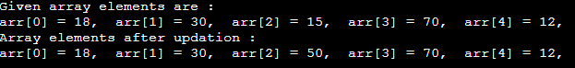

Complexity of Array operations

Time and space complexity of various array operations are described in the following table.

**Time Complexity**

|  |  |  |
| --- | --- | --- |
| **Operation** | **Average Case** | **Worst Case** |
| Access | O(1) | O(1) |
| Search | O(n) | O(n) |
| Insertion | O(n) | O(n) |
| Deletion | O(n) | O(n) |

**Space Complexity**

In array, space complexity for worst case is **O(n)**.

Advantages of Array

* Array provides the single name for the group of variables of the same type. Therefore, it is easy to remember the name of all the elements of an array.
* Traversing an array is a very simple process; we just need to increment the base address of the array in order to visit each element one by one.
* Any element in the array can be directly accessed by using the index.

Disadvantages of Array

* Array is homogenous. It means that the elements with similar data type can be stored in it.
* In array, there is static memory allocation that is size of an array cannot be altered.
* There will be wastage of memory if we store less number of elements than the declared size.

Conclusion

In this article, we have discussed the special data structure, i.e., array, and the basic operations performed on it. Arrays provide a unique way to structure the stored data such that it can be easily accessed and can be queried to fetch the value using the index.

2D Array

2D array can be defined as an array of arrays. The 2D array is organized as matrices which can be represented as the collection of rows and columns.

However, 2D arrays are created to implement a relational database look alike data structure. It provides ease of holding bulk of data at once which can be passed to any number of functions wherever required.

How to declare 2D Array

The syntax of declaring two dimensional array is very much similar to that of a one dimensional array, given as follows.

1. **int** arr[max_rows][max_columns];

however, It produces the data structure which looks like following.

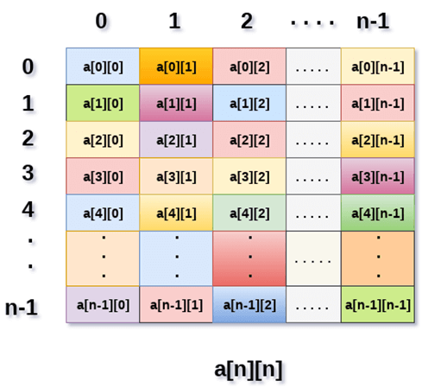

Above image shows the two dimensional array, the elements are organized in the form of rows and columns. First element of the first row is represented by a[0][0] where the number shown in the first index is the number of that row while the number shown in the second index is the number of the column.

How do we access data in a 2D array

Due to the fact that the elements of 2D arrays can be random accessed. Similar to one dimensional arrays, we can access the individual cells in a 2D array by using the indices of the cells. There are two indices attached to a particular cell, one is its row number while the other is its column number.

However, we can store the value stored in any particular cell of a 2D array to some variable x by using the following syntax.

**int** x = a[i][j];

where i and j is the row and column number of the cell respectively.

We can assign each cell of a 2D array to 0 by using the following code:

**for** ( **int** i=0; i<n ;i++)

{

**for** (**int** j=0; j<n; j++)

    {

        a[i][j] = 0;

    }

}

Initializing 2D Arrays

We know that, when we declare and initialize one dimensional array in C programming simultaneously, we don't need to specify the size of the array. However this will not work with 2D arrays. We will have to define at least the second dimension of the array.

The syntax to declare and initialize the 2D array is given as follows.

**int** arr[2][2] = {0,1,2,3};

The number of elements that can be present in a 2D array will always be equal to (**number of rows * number of columns**).

**Example :** Storing User's data into a 2D array and printing it.

**C Example :**

#include <stdio.h>

**void** main ()

{

**int** arr[3][3],i,j;

**for** (i=0;i<3;i++)

    {

**for** (j=0;j<3;j++)

        {

            printf("Enter a[%d][%d]: ",i,j);

            scanf("%d",&arr[i][j]);

        }

    }

    printf("\n printing the elements ....\n");

**for**(i=0;i<3;i++)

    {

        printf("\n");

**for** (j=0;j<3;j++)

        {

            printf("%d\t",arr[i][j]);

        }

    }

}

Java Example

**import** java.util.Scanner;

publicclass TwoDArray {

publicstaticvoid main(String[] args) {

**int**[][] arr = newint[3][3];

    Scanner sc = **new** Scanner(System.in);

**for** (inti =0;i<3;i++)

    {

**for**(intj=0;j<3;j++)

        {

            System.out.print("Enter Element");

            arr[i][j]=sc.nextInt();

            System.out.println();

        }

    }

    System.out.println("Printing Elements...");

**for**(inti=0;i<3;i++)

    {

        System.out.println();

**for**(intj=0;j<3;j++)

        {

            System.out.print(arr[i][j]+"\t");

        }

    }

}

}

C# Example

using System;

**public** **class** Program

{

**public** **static** **void** Main()

    {

**int**[,] arr = **new** **int**[3,3];

**for** (**int** i=0;i<3;i++)

        {

**for** (**int** j=0;j<3;j++)

            {

                Console.WriteLine("Enter Element");

                arr[i,j]= Convert.ToInt32(Console.ReadLine());

            }

        }

        Console.WriteLine("Printing Elements...");

**for** (**int** i=0;i<3;i++)

        {

            Console.WriteLine();

**for** (**int** j=0;j<3;j++)

            {

                Console.Write(arr[i,j]+" ");

            }

        }

    }

}

Mapping 2D array to 1D array

When it comes to map a 2 dimensional array, most of us might think that why this mapping is required. However, 2 D arrays exists from the user point of view. 2D arrays are created to implement a relational database table lookalike data structure, in computer memory, the storage technique for 2D array is similar to that of an one dimensional array.

The size of a two-dimensional array is equal to the multiplication of number of rows and the number of columns present in the array. We do need to map two dimensional array to the one dimensional array in order to store them in the memory.

A 3 X 3 two dimensional array is shown in the following image. However, this array needs to be mapped to a one dimensional array in order to store it into the memory.

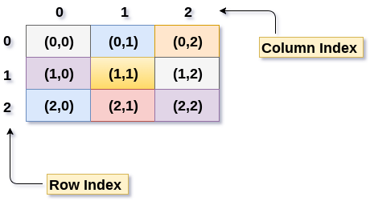

There are two main techniques of storing 2D array elements into memory

1. Row Major ordering

In row major ordering, all the rows of the 2D array are stored into the memory contiguously. Considering the array shown in the above image, its memory allocation according to row major order is shown as follows.

DS 2D Array

first, the 1st row of the array is stored into the memory completely, then the 2nd row of the array is stored into the memory completely and so on till the last row.

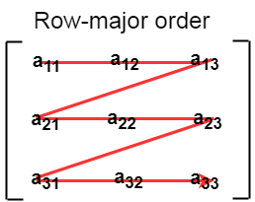

2. Column Major ordering

According to the column major ordering, all the columns of the 2D array are stored into the memory contiguously. The memory allocation of the array which is shown in in the above image is given as follows.

DS 2D Array

first, the 1st column of the array is stored into the memory completely, then the 2nd row of the array is stored into the memory completely and so on till the last column of the array.

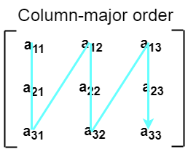

Calculating the Address of the random element of a 2D array

Due to the fact that, there are two different techniques of storing the two dimensional array into the memory, there are two different formulas to calculate the address of a random element of the 2D array.

By Row Major Order

If array is declared by a[m][n] where m is the number of rows while n is the number of columns, then address of an element a[i][j] of the array stored in row major order is calculated as,

Address(a[i][j]) = B. A. + (i * n + j) * size

where, B. A. is the base address or the address of the first element of the array a[0][0] .

**Example :**

a[10...30, 55...75], base address of the array (BA) = 0, size of an element = 4 bytes .

Find the location of a[15][68].

Address(a[15][68]) = 0 + ((15 - 10) x (68 - 55 + 1) + (68 - 55)) x 4

= (5 x 14 + 13) x 4

= 83 x 4

= 332 answer

By Column major order

If array is declared by a[m][n] where m is the number of rows while n is the number of columns, then address of an element a[i][j] of the array stored in row major order is calculated as,

1. Address(a[i][j]) = ((j*m)+i)*Size + BA

where BA is the base address of the array.

**Example:**

A [5 ... +20][20 ... 70], BA = 1020, Size of element = 8 bytes.

Find the location of a[0][30].

Address [A[0][30])

 = ((30-20) x 24 + 5)  x 8 + 1020   =  245 x 8 + 1020 = 2980 bytes